Spam Detection and Filteration

Project Synopsis

INDEX

 | TOPICS | PAGE NO.
1. | INTRODUCTION
2. | ANALYSIS  - Objective  - Working  - Software Requirement Specification  - Software Engineering Paradigm  - PERT Chart  - GANTT Chart  - Software Development Life Cycle
3. | DESIGN  - Algorithm & Flow Chart  - Design of Data Base iii.UML Diagram  - DFD  - Class Diagram  - Activity Diagram  - ER Diagram  - Control Flow Diagram  - System Flow Diagram
4. | TOOLS DESCRIPTION
5. | RESULT
6. | TESTING
7. | CONCLUSION
8. | REFRENCES

Introduction:

Overview:
The digital communication landscape has evolved rapidly, with an overwhelming amount of information exchanged daily. Consequently, users face the challenge of managing unwanted messages, including spam emails and SMS. The Email and SMS Spam Classifier project aims to develop a robust solution that effectively distinguishes between spam and legitimate communications. This document outlines the project’s objectives, analysis, design, implementation, and testing methodologies.

Problem Statement:

Problem:
Businesses and individuals frequently face challenges in efficiently managing and filtering spam emails and SMS messages. The volume of unsolicited messages can overwhelm users, making it difficult to identify and respond to genuine communications. Manually sifting through these messages can be time-consuming and frustrating, often leading to missed opportunities or increased exposure to phishing attempts.

Solution:
The Email and SMS Spam Classifier is designed to automate the identification and filtering of spam messages, allowing users to focus on legitimate communications. This platform employs machine learning algorithms and natural language processing techniques to analyze incoming messages in real time. Here’s how the platform addresses the problem:
- Reduced Manual Work:
  - Users are relieved from the burden of manually identifying spam messages. The classifier automatically categorizes incoming emails and SMS, allowing users to quickly review only the legitimate ones.

- Improved Efficiency:
  - The platform can process messages rapidly, leveraging advanced algorithms to classify spam with high accuracy. This speed ensures that users receive timely notifications and can act on genuine communications without delay.

- Enhanced Information Access:
  - Users can access summaries and key insights about classified messages, enabling them to understand why a message was flagged as spam. This transparency fosters trust in the automated system.
- Scalability:
  - The platform is designed to handle a significant volume of messages, making it suitable for businesses with extensive communication needs. As user demand grows, the classifier can scale effectively to accommodate increased traffic.

Scope:
The project aims to develop an Email and SMS Spam Classifier that includes essential functionalities such as:
- User Interface:
  - A user-friendly dashboard where users can view classified messages, access summaries, and adjust spam detection settings.
- Secure Authentication:
  - Implementation of robust user authentication protocols to protect user data and maintain privacy.
- Message Classification:
  - Algorithms for real-time spam detection and classification based on machine learning techniques.
- Feedback Mechanism:
  - A feature that allows users to provide feedback on the accuracy of the spam classifications, helping improve the system over time.
- Reporting:
  - Generation of reports that summarize spam detection metrics, user feedback, and system performance.

Exclusions:
The initial project scope does not include advanced features such as:

- Complex Billing Systems:
  - The platform will not incorporate detailed billing features at this stage, focusing instead on providing a straightforward subscription model.
- Advanced User Management:
  - While basic user management will be implemented, features such as multi-user support and detailed role permissions will be excluded from the first version of the platform.

Analysis:

Objective of Project:
The primary objective of the Email and SMS Spam Classifier is to develop an efficient machine learning model that accurately classifies messages as spam or non-spam. The project aims to:

- Enhance user experience by reducing spam interference in communication.
- Achieve a high accuracy rate in classification, aiming for over 90%.
- Provide a user-friendly interface for easy interaction and feedback.

Working:
The spam classifier employs natural language processing (NLP) techniques and machine learning algorithms to process and analyze message content. The working process includes:
- Data Collection: Gathering a labeled dataset of spam and non-spam messages.
- Data Preprocessing: Cleaning and preparing the data, including tokenization, stemming, and removing stop words.
- Feature Extraction: Transforming text data into numerical features using methods like Bag of Words or TF-IDF.
- Model Training: Training machine learning algorithms (e.g., Naive Bayes, Support Vector Machines) on the processed data.
- Prediction: Classifying new messages based on the trained model.

SRS :

1. Introduction

1.1 Project Title:
Email and SMS Spam Classifier

1.2 Description:
This document outlines the requirements for an automated Email and SMS Spam Classifier. The platform will enable users to efficiently filter and manage spam messages, enhancing their communication experience by minimizing unwanted distractions.

2. Overall Description

2.1 Product Perspective:
This platform is designed for individuals and businesses looking to optimize their messaging experience. It provides a streamlined solution for classifying and filtering spam emails and SMS messages, ensuring users can focus on legitimate communications.

2.2 Product Functions:
- Message Filtering: Automatically classify incoming emails and SMS messages as spam or legitimate.
- User Feedback: Allow users to report misclassified messages, helping improve the classification algorithm.
- Dashboard: Provide users with an intuitive dashboard to view and manage classified messages.
- Analytics: Generate reports on spam detection metrics, including the number of messages classified as spam and user feedback.
- Secure Authentication: Implement secure user authentication to protect user data and maintain privacy.
- Responsive Design: Ensure the platform is accessible from any device, including desktops, tablets, and smartphones.

2.3 User Characteristics:
The target users include:
- General Users: Individuals looking to declutter their inboxes and messaging apps.
- Business Professionals: Users managing high volumes of emails and texts, seeking to enhance productivity.
- IT Administrators: Personnel in organizations responsible for maintaining communication systems and ensuring security against phishing attacks.

3. Specific Requirements

3.1 Functional Requirements:

3.1.1 Message Classification:
- The platform should automatically classify incoming emails and SMS messages with a high accuracy rate of at least 95%.
- Users should be able to customize spam filters based on predefined keywords or sender information.

3.1.2 User Interaction:
- Users should be able to report false negatives (legitimate messages marked as spam) and false positives (spam messages not detected).
- The platform should provide a history log of classified messages for user review.

3.1.3 Security:
- The platform should implement secure user authentication to protect sensitive user data.
- All user data and classified messages should be encrypted both at rest and in transit.

3.1.4 User Interface:
- The platform should have a user-friendly and responsive interface accessible from various devices.
- The interface should feature clear instructions and intuitive navigation for ease of use.

3.2 Non-Functional Requirements:

3.2.1 Performance:
- The platform should process incoming messages and classify them within a timeframe of 5 seconds.
- The platform must be scalable to accommodate a growing number of users and message volume without degradation in performance.

3.2.2 Availability:
- The platform should be available to users 24/7, with a target uptime of 99.9% and minimal downtime.
- A disaster recovery plan should be in place to ensure data integrity and continuity of service in the event of failures.

3.2.3 User Experience:
- The platform should be designed to minimize the learning curve, allowing users to navigate and utilize features easily.
- The system should provide clear feedback on actions taken, including confirmations of report submissions and updates on classification changes.

Feasibility Study for the Project:

1. Introduction
This feasibility study explores the potential of developing an Email and SMS Spam Classifier that enables users to efficiently filter and manage spam messages. The study evaluates the technical feasibility, market viability, and economic viability of the project.

2. Technical Feasibility
- Technology Stack: The selected technologies, including Python for backend development, TensorFlow or Scikit-learn for machine learning algorithms, and a React-based frontend, are robust and widely used in the industry. These technologies are suitable for building an efficient spam classification system.
- Open Source Libraries: Leveraging open-source libraries such as NLTK for natural language processing and TensorFlow for machine learning will reduce development costs and accelerate the implementation process.
- Complexity: While the platform aims to implement advanced spam classification features, the project can be broken down into manageable components, making the overall technical complexity moderate.

3. Market Viability
- Market Need: There is a significant demand for effective spam filtering solutions, particularly as users face increasing volumes of unwanted emails and messages. A platform that provides accurate spam detection can significantly enhance users' messaging experiences.
- Competition: Although various spam filtering solutions exist, many rely on basic filtering techniques. The integration of machine learning algorithms for improved accuracy could provide a competitive edge for this platform.
- Target Market: The target audience includes general users seeking to declutter their inboxes, business professionals managing numerous communications, and IT administrators responsible for maintaining secure communication systems.

4. Economic Viability
- Cost of Development: Utilizing open-source technologies minimizes initial development costs. However, expenses will include cloud hosting, subscriptions for machine learning services, and ongoing maintenance of the platform.
- Revenue Model: The platform could adopt a subscription-based revenue model, offering different tiers based on features such as advanced filtering options, analytics, and enhanced user support.
- Potential Challenges: Initial challenges may include user acquisition and establishing brand recognition in a crowded market. Effective marketing strategies and partnerships may be necessary to overcome these hurdles.

Software Engineering Paradigm: Agile Development:
The project adopts the Agile software development paradigm, an iterative and incremental approach to software development. Agile methodologies prioritize flexibility, collaboration, and responsiveness to change, enabling teams to deliver high-quality software efficiently and adapt to evolving requirements and user needs.

Key Principles:
1. Iterative Development: The project is divided into small, manageable iterations or sprints, typically lasting 1-4 weeks. Each sprint focuses on delivering a set of prioritized features or user stories, allowing for rapid feedback and iteration.
2. Continuous Feedback: Stakeholder feedback is solicited and incorporated throughout the development process, ensuring alignment with user expectations and project goals. Regular demos and reviews facilitate open communication and collaboration.
3. Adaptive Planning: Requirements and priorities are subject to change, and the project adapts accordingly. The development team remains responsive to feedback, emerging requirements, and market dynamics, adjusting plans and priorities as needed.
4. Cross-functional Teams: The project team consists of cross-functional members, including developers, designers, testers, and domain experts. Collaboration and communication between team members are encouraged to foster shared understanding and collective ownership.
5. Incremental Delivery: Working software is delivered incrementally at the end of each sprint, providing tangible value to users and stakeholders early in the development process. This allows for quick validation of assumptions and enables course correction as needed.
6. Continuous Improvement: The Agile mindset emphasizes continuous improvement and learning. Retrospectives are held at the end of each sprint to reflect on what went well, what could be improved, and actions to take in the next iteration.
7. Empirical Process Control: The project management approach is empirical, relying on transparency, inspection, and adaptation. Progress is measured based on working software, and decisions are informed by empirical data and feedback.

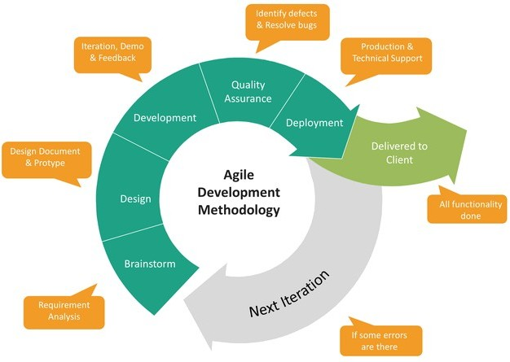
Design:

Algorithm and Flowchart :

1. Text Extraction and Parsing
The first step in the spam classification process involves extracting and parsing the text content from emails and SMS messages. This step is crucial for converting the raw text data into a format suitable for analysis. The key components include:
- Text Extraction Algorithms:
  - Optical Character Recognition (OCR): While OCR is typically used for scanned documents, in the context of email and SMS, it might involve extracting text from image-based messages or attachments (if applicable). This ensures that all content is accessible for classification.
- Parsing Algorithms:
  - Message Structure Analysis: Algorithms are employed to identify various elements within the text, such as sender information, subject lines, body content, and any embedded links. This helps in understanding the context of the message, which can be vital for accurate classification.

2. Information Retrieval
Once the text is extracted and parsed, the next phase is to retrieve relevant information based on user queries or during the classification process. This involves several algorithms:
- Keyword Matching:
  - The system matches keywords extracted from the incoming messages against a predefined list of spam-related keywords. This initial filtering helps in quickly identifying potential spam messages based on common spam indicators.
- Information Retrieval Models:
  - TF-IDF (Term Frequency-Inverse Document Frequency): This algorithm ranks the relevance of specific words in the messages. By analyzing the frequency of terms in the spam dataset versus legitimate emails, the classifier can determine which terms are more indicative of spam.

3. Document Summarization (Optional)
In cases where users may want insights about the spam detection process or the characteristics of identified spam messages, document summarization can be employed:
- Extractive Summarization:
  - This approach identifies and extracts key sentences from the email or SMS that represent spam characteristics effectively. For instance, phrases like “Congratulations! You’ve won a prize!” might be flagged as significant indicators of spam.
- Abstractive Summarization:
  - Advanced models can generate concise summaries that capture the essence of the spam message, providing a brief overview of why a particular message was classified as spam.

4. Machine Learning Model Integration
At the heart of the spam classifier is the integration of machine learning models trained on labeled datasets. This process includes:
- Feature Extraction:
  - Algorithms transform the text data into numerical features, such as:
    - Bag of Words
    - Word Embeddings (e.g., Word2Vec, GloVe)
- Model Training:
  - Various machine learning algorithms, including:
    - Naive Bayes: A probabilistic classifier that applies Bayes' theorem, particularly effective for text classification tasks.
    - Support Vector Machines (SVM): A powerful model that finds the hyperplane that best separates spam from non-spam messages.

5. User Interaction and Feedback Loop
The system also incorporates user interaction to enhance accuracy through a feedback loop:
- Query Formulation:
  - The platform transforms user queries regarding spam messages into a format that the machine learning model can process.
- Response Processing:
  - After the model classifies a message, it presents the results to the user, potentially highlighting key indicators that led to the spam classification. User feedback can be collected to improve the model further.

Flowchart
A flowchart for the Email and SMS Spam Classifier can be constructed to visualize the above steps. The flowchart would include:
- Start
- Text Extraction and Parsing
  - OCR for attachments (if necessary)
  - Parse message structure
- Information Retrieval
  - Keyword Matching
  - Apply TF-IDF model
- Classification
  - Feature Extraction
  - Model Prediction (Naive Bayes/SVM)
- User Interaction
  - Present results and key indicators
  - Collect user feedback
- Optional: Document Summarization
  - Extractive and Abstractive Summarization (if applicable)
- End
Modular Description :

Modular Architecture
The Email and SMS Spam Classifier platform utilizes a modular architecture, consisting of independent, self-contained units that collaborate to achieve the overall functionality. Below is a breakdown of the key modules:
- Frontend: Built with React, this module manages user interactions, handles the user interface (UI), and presents the application’s functionalities. It ensures a seamless experience for users as they engage with the spam classification features.
- API Layer: This layer acts as a communication bridge between the frontend and backend services, possibly implemented using a framework like Express.js. It receives user requests from the frontend, interacts with backend services, and returns processed data for display.
- Backend Services: This includes several integrated modules that work together:
  - Authentication: This module manages user registration, login, and authorization, ensuring secure access to the platform's features.
  - Spam Detection Engine: This core module utilizes machine learning algorithms to analyze incoming messages (emails/SMS) and classify them as spam or legitimate, leveraging training data to improve accuracy.
  - Data Storage: A database solution (e.g., PostgreSQL or MongoDB) is employed to store user data, message information, and classification results, ensuring efficient data retrieval and management.
  - Analytics Module: This module tracks user interactions and spam detection performance, providing insights that help improve the classification algorithms over time.
- Styling Framework: A CSS framework (like Tailwind CSS) may be used to simplify the styling of UI components, offering pre-built utility classes for rapid design implementation.

Benefits of Modular Architecture
- Maintainability: Independent modules facilitate easier maintenance, updates, and testing, allowing for a more streamlined development process.
- Scalability: Individual modules can be scaled independently to accommodate a growing user base, ensuring the platform remains responsive under increased load.
- Reusability: Modules can potentially be reused in other projects that require similar functionalities, enhancing development efficiency.
- Development Efficiency: Modular development encourages better code organization and simplifies collaboration among developers, promoting a more effective workflow.
UML Diagram :

DFD:

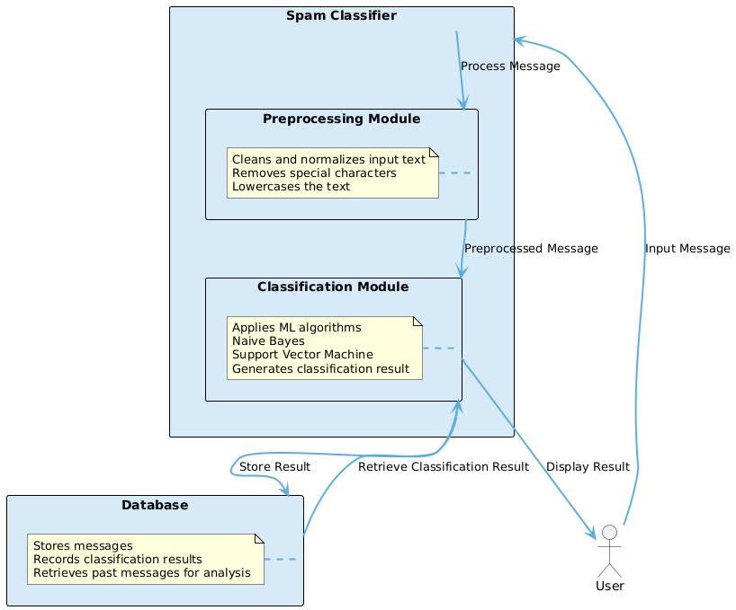
Class Diagram:
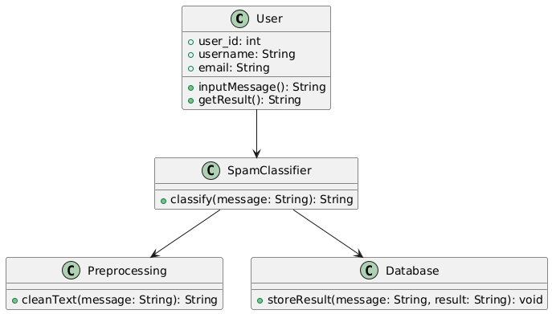

Activity Diagram :

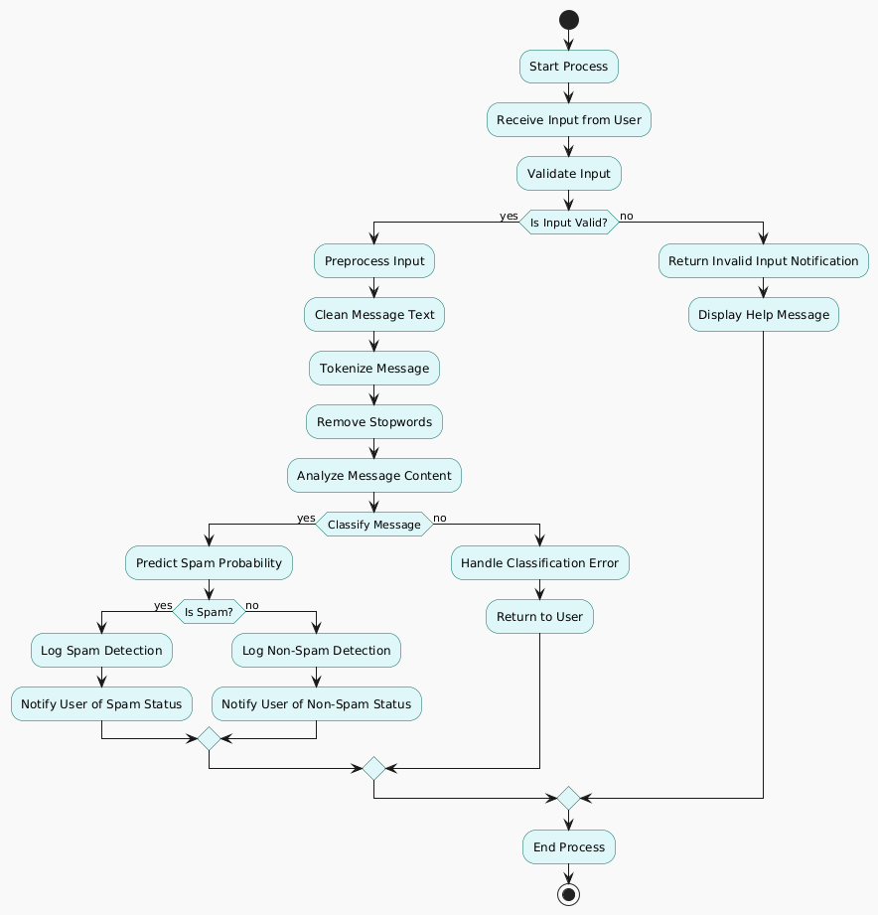

ER Diagram :

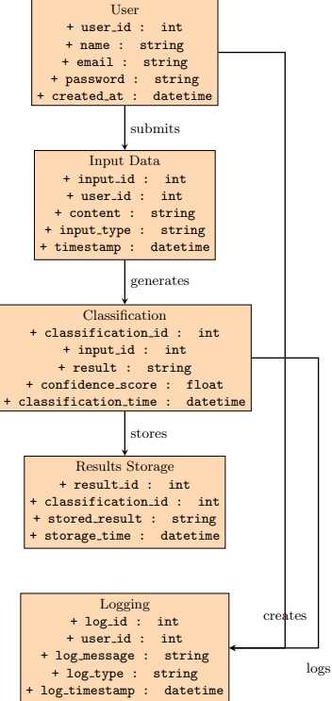

Control Flow Diagram:

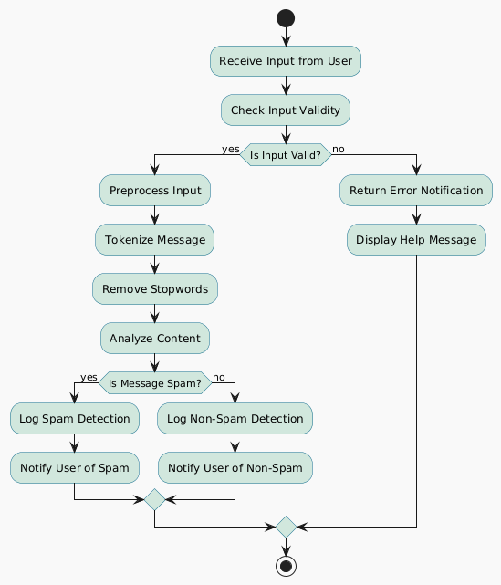

System Flow Diagram :

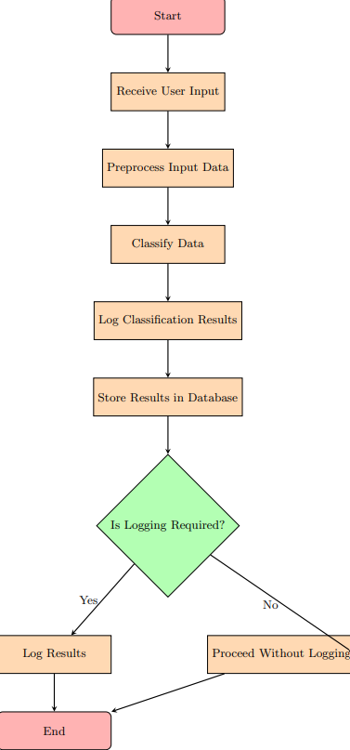

Implementation:

Tools Description :

Frontend Development
Streamlit: This tool provides a simple yet powerful interface for building the frontend of the application. It allows developers to create interactive web applications with minimal code, focusing on data science and machine learning workflows.

Backend Development
Python: The core programming language for developing the backend, managing data processing, model integration, and API interactions.

Scikit-learn: A robust machine learning library in Python, utilized to implement the spam detection algorithms. It offers tools for model training, testing, and deployment, allowing for efficient spam classification.

Natural Language Toolkit (NLTK): This open-source library is used for text processing and natural language processing (NLP) tasks like tokenization, stemming, and feature extraction from the message content.

Testing:

Unit testing is essential in ensuring the robustness of our spam classifier. The following test cases have been implemented to validate each module of the system.
Test Cases Applied in Our Project:

1. Email Upload and Processing:

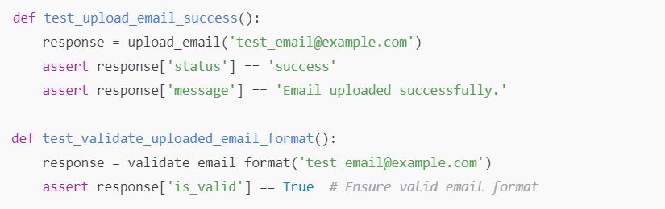

2. Spam Detection:

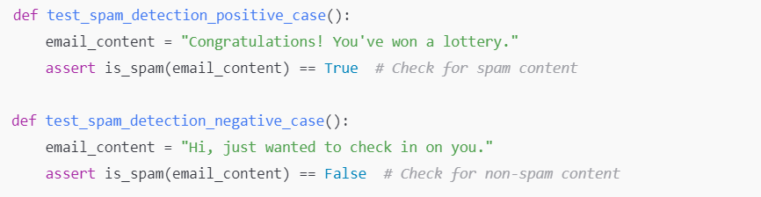

3. SMS Upload and Processing:

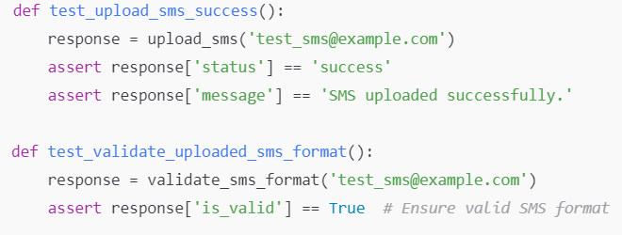

4. Text Classification Accuracy:

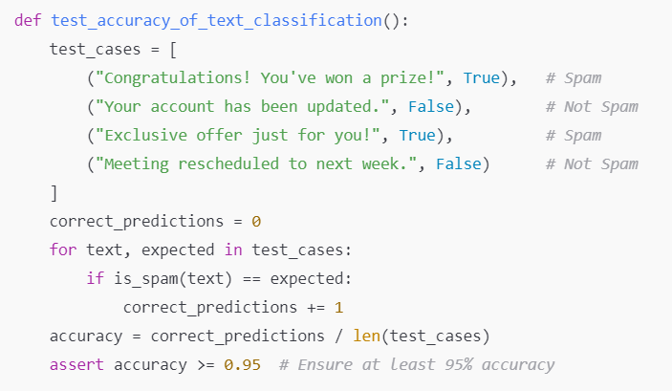

5. False Positive Rate:

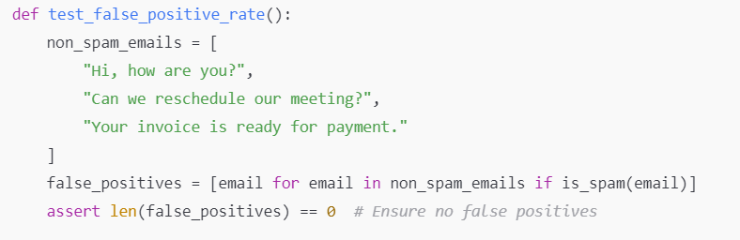

6. Logging and Reporting:

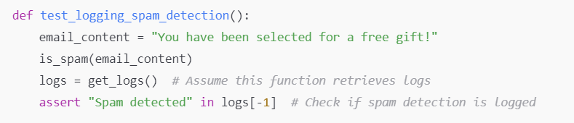

Conclusion:

The Email Spam Classifier platform significantly enhances email management by effectively detecting and filtering spam. Utilizing advanced AI algorithms, it accurately analyzes email content to classify messages, helping users focus on relevant communications.
The user-friendly interface ensures a seamless experience, with clear instructions that promote efficient usage and high satisfaction. By combining robust frontend technologies like React with powerful backend tools, the platform is both efficient and reliable, supported by thorough unit testing.
Overall, the Email Spam Classifier showcases the transformative potential of AI in revolutionizing email management, streamlining communication, and improving user experience.

References:

1. Murphy, K. P. (2012). Machine Learning: A Probabilistic Perspective. MIT Press.
2. Jurafsky, D., & Martin, J. H. (2019). Speech and Language Processing (3rd ed.). Pearson.
3. Python Software Foundation. (2023). Python Language Reference. Retrieved from Python.org
4. Scikit-learn Developers. (2023). Scikit-learn Documentation. Retrieved from scikit-learn.org
5. NLTK Developers. (2023). NLTK Documentation. Retrieved from nltk.org
6. Streamlit Developers. (2023). Streamlit Documentation. Retrieved from streamlit.io
7. Google Developers. (2023). Google Colab Documentation. Retrieved from colab.research.google.com

